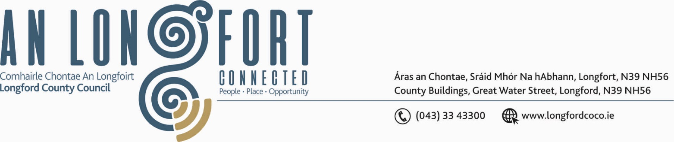

2u Marta 2017.

Chuig: Gach Ball don Chomhairle.

A Chomhairleoir,

Iarrtar ort bheith i láthair ag Cruinniú Míosuil Chomhairle Chontae Longfoirt a tionólfar i Seomra na Comhairle, Aras an Chontae, Longfoirt ar an Chéadaoin, 8u Marta 2017 ag 4.00 p.m chun gnó a dhéanamh d’réir an Chláir thíos.

You are requested to attend the Monthly Meeting of Longford County Council to be held in the Council Chamber, Aras an Chontae, Great Water Street, Longford, on Wednesday, 8th March 2017 at
4.00 p.m. to transact business, as set out on the Agenda.

Mise le meas,
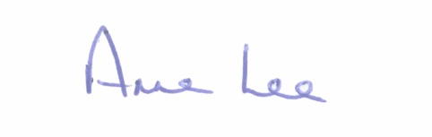

_______________
Anne Lee,
Meetings Administrator.



C L A R

Prayer before Meeting.

- Confirmation of Minutes of the following Meeting of Longford County Council –

- Monthly Meeting held on the 8th February 2017 – copy enclosed.

2. Matters arising from Minutes.

3. To note Chief Executive Orders. (Summary herewith)

4. To note Monthly Management Report - Report to follow.

5. To note adopted Minutes of Corporate Policy Group Meeting held on
11th January 2017 – copy enclosed.

6. Housing, Infrastructure, Environment & Emergency Services.

- To note adopted Minutes of Housing Services Strategic Policy Committee Meeting held on
the 7th November 2016 - copy enclosed.

- Consideration of disposal of Rural House at Carrollbrennan, Newtowncashel, Co.Longford to Gavin Murphy, 5 Brookside Gardens, Rush, Co. Dublin in accordance with the terms of Section 183 of the Local Government Act 2001 issued on the 18th November 2016.

- Consideration of disposal of Freehold Interest of No. 45 St. Michael’s Road, Longford to John Mimnagh in accordance with the terms of Section 183 of the Local Government Act 2001 issued on the 7th February 2017.

- Consideration of disposal of Freehold Interest of No. 8 St. Mary’s Terrace, Longford to Anne Reilly Cassin in accordance with the terms of Section 183 of the Local Government Act 2001 issued on the 13th February 2017.

- Consideration of Draft Anti-Social Behaviour Strategy 2016 – 2021 - copy enclosed.

/over...
- Consideration of the following recommendations from Housing Services Strategic Policy Committee -

(i) “That the Department of Housing, Planning, Community & Local Government review the income ceiling for Social Housing Support.” - Report enclosed.

(ii) “That appropriate speed controls be provided in Housing Estates.”

- Notice of Motion submitted by Councillor Paul Ross -

“That Longford County Council writes to Irish Water to urgently ensure that the Water Main in Ballymahon is completely replaced on the Main Street in 2017.”

7. Economic and Community Development, Planning, Human Resources & Corporate
Services, Cultural & Recreational Services.

- Attendance of Paul Veale, Regional Manager, IDA.

- To note Planning Applications received since January meeting of the Council.

- To note adopted Minutes of Economic Development and Enterprise Strategic Policy Committee meeting held on the 24th October 2016 - copy enclosed

- To note adopted Minutes of Planning and Development and Cultural Strategic Policy Committee meeting held on the 29th November 2016 - copy enclosed.

- Consideration of Recommendation from Economic Development and Enterprise Strategic Policy Committee in relation to proposed alterations and additions to the Business Incentive Scheme (BIS) - Report enclosed.

- Consideration of Longford County Council submissions for Ireland 2040 – Our Plan - National Planning Framework - copy enclosed.

- Consideration of Manager's Report on the Review of County Development Plan 2015-2021 - Report enclosed.

- Part 8 Planning consideration of an Amenity Walkway through the Cutaway Bog surrounding Corlea Trackway at Corlea, Mosstown and Cloonbreaney, Keenagh - Report enclosed.

- Update on Northern Quarter.

/over...

- Consideration of Tourism Strategy - copy enclosed.

- Ratification of Ms Aine Bohan, Department of Social Protection, to replace Mr. Des Henry as a member of Longford Local Community Development Committee (LCDC)

- Ratification of Ms Shauna Doherty (Adult Education Officer), Longford & Westmeath Education and Training Board,to replace Mr. Maria Fox as a member of Longford Local Community Development Committee (LCDC)

- Appointment of a Member to replace Councillor P.J. Reilly on the Board of Longford Community Resources CLG.

- Consideration of recommendation from Corporate Policy Group -

Request from Councillor Mick Cahill, Cathaoirleach.

“In accordance with adopted Civic Honours Protocol, that Longford County Council hosts a Civic Reception for Marguerite Donlon in honour of her achievements in the world of Ballet.”

- Notice of Motion submitted by Councillor Micheal Carrigy -

“I call on the Minister for Transport, Tourism and Sport Minister Shane Ross to instruct Failte Ireland to immediately start the process of setting up the Lakeland District brand which must include Longford Westmeath and Cavan.”

8. Finance & Information Systems.

- To note Public Liability Claims received during February 2017 – Report enclosed.

- Consideration of the 2017-2019 Capital Budget - Report enclosed.

(c) Presentation of 2016 Audit Committee Annual Report by Mr. Patrick Groarke, Chairperson, Audit Committee - Report enclosed.

/over...

9. General

Notice of Motion submitted by Councillor Gerry Warnock.

“I propose that we write to the Minister for Jobs, Enterprise & Innovation, and to the Office of An Taoiseach, to review the legislation (or lack of) surrounding “Zero Hour Contracts” to provide for, in specific cases, a minimum working block of 6 hours per day. Such cases should include businesses that continue to operate outside of normal day time working hours (8.00am – 6.00pm). The current lack of specific regulation is creating the possibility for the exploitation of employees because of the great uncertainty surrounding their conditions of employment. This can be detrimental for work/life balance, securing finance, in particular instances where this uncertainty impairs childcare responsibilities.”

10. Votes of sympathy.

11. Training -

Consideration of Report from Corporate Policy Group.

